BIKE DROVERS



TITLE:

This program offers a variety of two wheelers of almost all brands and accessories at a small and digital place. It has to maintain a big record of motorcycles, accessories and available dealers of a particular area.

Problem and reason:

As we see in regular life when someone have to buy a new motorcycle then he/she have to do a lot of search to select an appropriate bike, sometime he may not able to find the best dealers or complete information about product in all aspect.

Main objective:

The aim of this project is to help the customers in selection of their vehicles, maintaining and updating the database. It displays the motor bike database i.e. the items available and stock available in a agency . It updates the stock according to the changes made in supply. Details of the dealers are also maintained along with all.

This app also has an option for who want to be an automobile dealer and customer can rate their performance on the basis of service provide by dealer or any bike agency.

Scope:

It has a wide scope in the future it can connect us with the world among motorcycle market and in future it may be with all automobiles including spacecraft, as we know space travelling is no more a dream for humans. So this project can play a vital role in field of automobile industry especially after corona when people want to avoid physical contact so this provides them everything on their home with all information of every motorcycle and dealers.

This project helps to maintain proper relationship between dealers and customers which we feel is somehow missing and this create lot of opportunities for new dealers who find difficulty in their establishment in this market which is already holded by old and well established dealers. It is easy to reach the masses through software rather than manually.

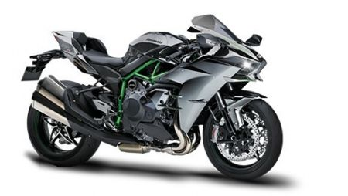

Working:

This project is working on the basis of choices. This program gives us the choice which we select and shows us the result accordingly and provide details of everything so that people can avoid fraud and able to select best option for them.

Hardware and software used:

Hardware:

* Pc for coding(windows 7 home basic)

Software:

* C++ compiler(turbo c++)
* Graphics file of c++

Limitations:

It is a simple coding based project where a user can run a program and then choose from options .It can be upgraded to a app module where a user can work on phone based applications.

Group:

* Archit garg
* Aryan patel
* Aryan Aggarwal
* Arpan malik